Registration is now open!
2024 “Earth Day” SPARK STEM DAY
Sign-up Today!

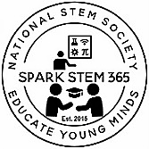
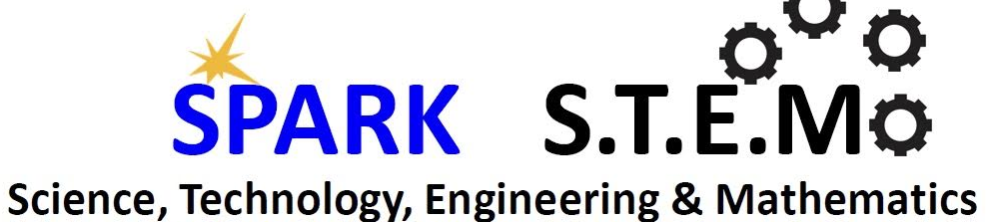

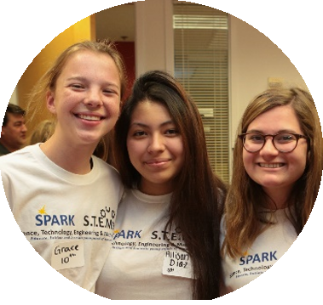
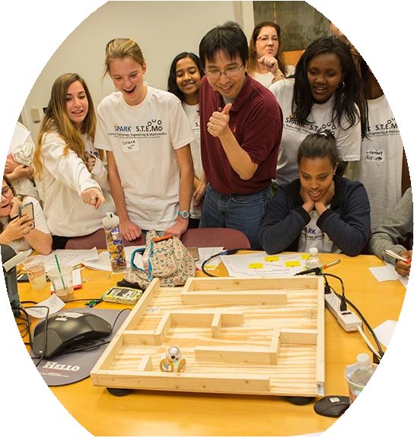
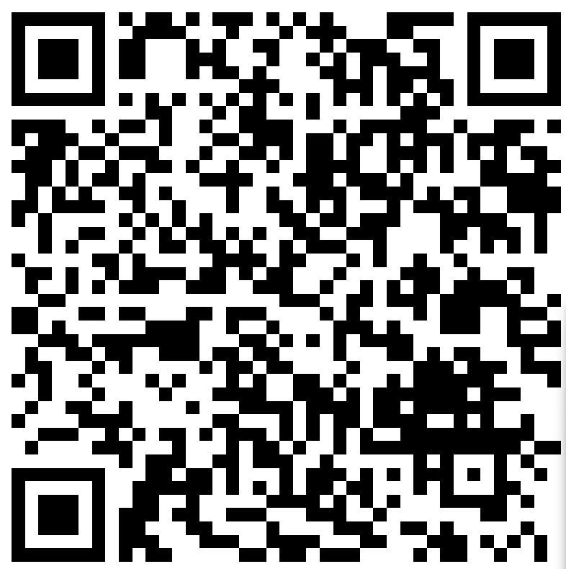
Educate | Initiate | Innovate
National STEM Society
a 501©3 nonprofit organization
is pleased to announce the next:
SPARK S.T.E.M DAY
April 2024
Theme: Earth Day
Orlando, Florida

This exciting opportunity will introduce girls and boys to STEM GO- LIVE science, technology, engineering, arts and mathematics careers and fields.

Visit www.nationalstemsociety.org for more details and how to register!
The purpose of this community initiative is to cultivate the interest of young girls and boys in grades 3rd through 12th to pursue higher education and careers in Science, Technology, Engineering and Mathematics (STEM) fields by introducing:
- A day of STEM “learn-n-play” concepts, games, and activities.
- Build self-confidence and engagement skills
- Corporate demonstrations
- How to work in a collaborative team effectively
- Professional STEM Career speakers & video cast
Scan QR Code to pre-register!

JOIN A SPARK STEM CLUB TODAY!
- FUN STEAM Exploration & Discovery
- LEARN STEAM Careers & Mentorship
- PLAY STEAM Hackathons, Labs, & Trips
Volunteer Today!
Ask us how?

Educate | Initiate | Innovate

